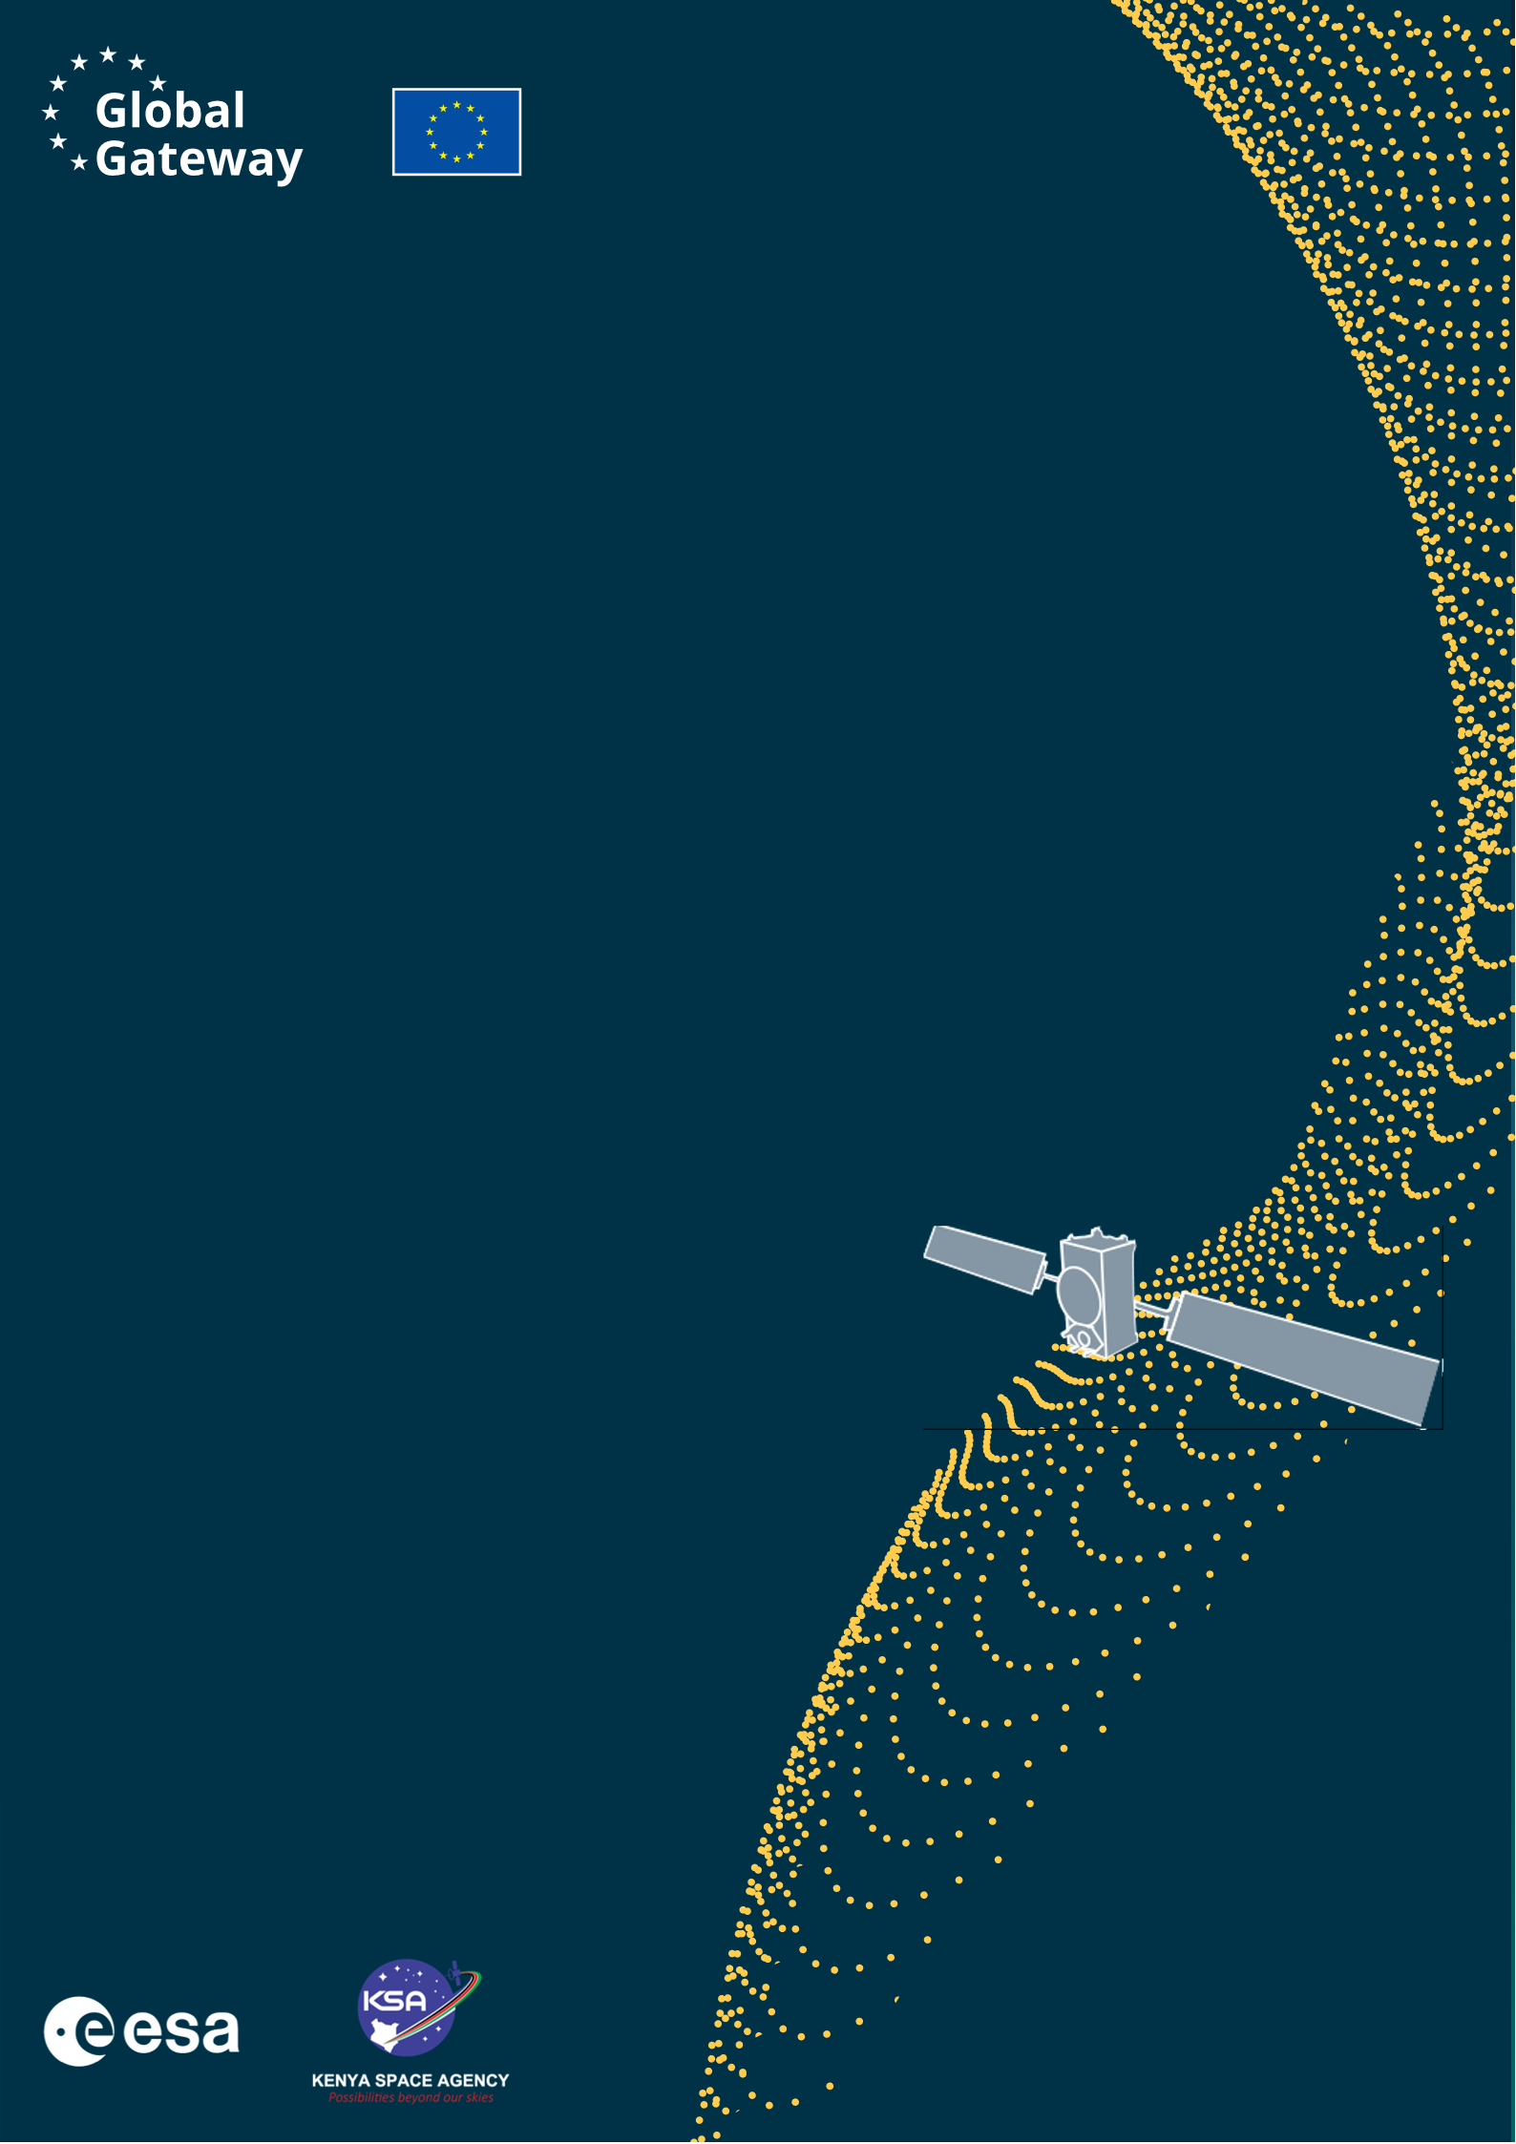
Africa–EU Space Partnership Programme
Africa Business Innovation Lab (ABIL)

ABIL EXPLORE
Application

The Africa Business Innovation Lab (ABIL) is an initiative under the Africa–EU Space Partnership Programme (AESPP) funded by the European Union (represented by European Commission’s DG-INTPA) within the Global Gateway initiative and delegated to European Space Agency (ESA) for the implementation in close collaboration with the Kenya Space Agency (KSA).

Table of contents
1. Executive Summary 8
2. Technical Proposal and Exploitation Pathway / Initial Business Case 9
2.1 Background and Experience (1 page) 9
2.2 Market Opportunity (3 pages) 9
2.3 Technology and Relevance to ABIL EXPLORE / EO Innovation (3 pages) 10
3. Activity Proposal 12
3.1 Milestone Planning 12
3.2 Work Breakdown 12
3.3 Cost Planning 12
3.4 Key Resources and Facilities 13
4. Management Proposal 14
General Management (1 page): 14
5. Annexes 15

FARMIQ PASTURE WATCH

ABIL EXPLORE Application

EXPLORE Open Call
Minimal Viable Product/Service
Exploitation Pathway / Initial Business Case

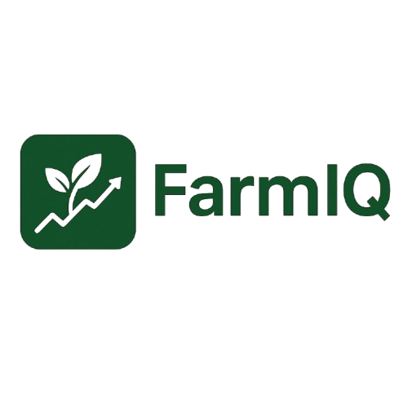
Kenya

Kenya

Project Name | : | FarmIQ Pasture Watch
Project Reference Number | :
Company Name(s) | : | FarmIQ |  | farmintelligentquotient
Project Manager(s) | : | Emmanuel Keter | Stanley Munene |  | Michael Mirera
Date of Submission | : | 16TH SEPTEMBER 2026

**Please delete the guidance notes (blue text) associated with
each section prior to submitting**

FarmIQ Team
AppCross Company Limited
P.O Box 25216, G.P.O Nairobi, Kenya
[E-Mail]
https://farmiq.solutions
EXPLORE Open Call - Kenya
African Business Innovation Lab (ABIL)
Represented by
STAM s.r.l.,
Piazza della Vittoria 14/25 – 16121
Genoa, Italy

For the attention of
ABIL EXPLORE Open Call Manager

SUBJECT: Application for ABIL EXPLORE Kenya
REF: [please insert your own reference number here]

Dear Madam, dear Sir,
In response to the ABIL EXPLORE Kenya Open Call for Proposals issued by STAM s.r.l. (hereinafter referred to as STAM), as manager of the African Business Innovation Lab (ABIL), AppCross Company Limited, developer of the FarmIQ digital farm management platform, is pleased to submit our proposal for the project named "FarmIQ Pasture Watch".

Please find included the following information:
- Requirements Checklist
- Executive Summary
- Technical Proposal and Exploitation Pathway / Initial Business Case
- Activity Proposal
- Management Proposal
- Annexes

1. We hereby declare that the Application is compliant with the Requirements set out in the Call for Proposals as shown in the Requirement Checklist below.
2. We hereby confirm that the contract conditions have been read, understood and accepted, and any of the Applicant’s terms and conditions do not apply.

Any queries relevant to the proposal are to be addressed to the attention of:

Emmanuel Kipngetich Keter
P.O Box 51439-00100
+254703260126
Emmanuel.keter@farmiq.solutions

Contact information of the person(s) who will be in charge of the day-to-day management:
[Name(s)]
[Address(es)]
[Phone]
[E-Mail]

Contact information of the legal representative who will be signing the contract:
Emmanuel Kipngetich Keter
P.O Box 51439-00100
+254703260126
Emmanuel.keter@farmiq.solutions

Signature(s): Date: 16TH SEPTEMBER 2026

ABIL EXPLORE General Application Requirements  (for EXPLORE Open Call Projects): | Compliance statement
The Applicant is a legal entity registered under the laws of Kenya. | Compliant
The Applicant is a Kenyan start-up, SME, University or Research Organisation developing or validating an innovative Earth Observation-related technology, application, service, method | Compliant
The Applicant is headquartered in Kenya | Compliant
The Applicant is fully compliant with Kenyan tax and social security obligations | Compliant
The Applicant does not conduct business activities promoting, or being related to alcohol abuse, tobacco, religion, politics, intolerance, violence, firearms, pornography, obscenity, gambling or illegal drugs. | Compliant
The Applicant is able to communicate in English. | Compliant
The Applicant states that the terms and conditions of the Draft ESA EXPLORE Funding Contract are accepted without any reservations. | Compliant
The Funding is linked to work packages within the ABIL EXPLORE project only | Compliant
The Applicant declares that the activities proposed under the submitted ABIL EXPLORE project are not and have not been funded through other means (e.g. National public funding, International public funding etc.) | Compliant
The Funding is granted in net amounts (not including VAT). | Compliant
The information provided in the application and in the supplementary data sheet is binding and forms the basis of the funding granted. Any changes in this information must be reported immediately and are subject to approval. | Compliant

I hereby declare that my application is compliant to the EXPLORE Open Call General Application Requirements.

Signature(s): Date: 16TH SEPTEMBER 2026

Data Protection

By submitting the application for ABIL EXPLORE Kenya, the Applicant gives by signing beneath this statement, free, specific, informed and unambiguous consent to STAM s.r.l. (Data Controller) with the controlling of the personal data contained in the proposal and business application in relation to this Open Call and for the purpose of possible selection for ESA EXPLORE Funding Kenya upon fulfilment of all requirements set in the Open Call. Such consent to the controlling of the personal data shall be permitted only for a necessary period up to a maximum duration of 1 (one) year upon signature of the present consent.

The Applicant shall have the right to information and the right of access to its personal data, right to rectification and erasure (right to be forgotten), right to restriction of processing, right to data portability, right to object, right not to be subject to a decision based solely on automated processing. The particularities of these rights are stipulated in the Regulation (EU) 2016/679 of the European Parliament and the Council.

The data subject shall have the right to withdraw its consent at any time. Such withdrawal of consent shall not affect the lawfulness of processing based on consent before its withdrawal. It shall be as easy to withdraw as to give consent. STAM as data Controller can be contacted via the e-mail address: privacy@stamtech.com.

The data subject has moreover the right to lodge a complaint with a supervisory authority established in each of the EU Member State as indicated in the GDPR legal framework.

I hereby give full consent to the above statement.

Name(s) and Signature(s): Date: 16TH SEPTEMBER 2026

Executive Summary

Entities involved:
The Applicant is AppCross Company Limited, a private limited company registered in Kenya (Company No. PVT-5JUZ2J2D, registered 5 June 2024, registered office in Karen, Nairobi). AppCross is the developer of FarmIQ, an operational farm management platform already covering dairy/livestock record-keeping, crop management, farm finance, task management, milk-yield analytics, credit scoring, and blockchain-based livestock records, used by Kenyan smallholder and medium-scale farmers.
The activity’s key partner is Miginon Farm, an approximately 25-acre dairy farm in Chepsir, Kipkeleon West, Kericho County, which has served as FarmIQ’s sole beta-testing and design partner since 13 May 2026. FarmIQ’s cow, feeding and farm-record features have been developed directly around Miginon Farm’s day-to-day operations, and Miginon Farm will serve as the primary pilot/validation site for the pasture-health module proposed under this activity. A signed Letter of Support from Miginon Farm is attached as an Annex.

EO innovative technology / asset / data / solution to be developed or transferred:
☒ Downstream segment (any kind of EO application, e.g. AI for EO)
The activity will develop and validate a satellite-based pasture and fodder health monitoring capability for Kenyan smallholder dairy farms, using free, open Sentinel-2 optical imagery (Copernicus programme, ESA) to compute vegetation health indices (NDVI/EVI) over each farm’s grazing and fodder plots — for example Napier grass, Boma Rhodes (hay) and Desmodium plots at the pilot farm. The resulting pasture-condition signal will be integrated directly into FarmIQ’s existing cow/feeding management module, turning a remote-sensing data product into an actionable, farmer-facing feeding recommendation and early warning of fodder shortage — rather than a standalone map or dashboard. The same signal is also expected to help farmers time fodder-cutting for silage-making, an activity the pilot farm already carries out with home-grown Napier grass and Boma Rhodes hay.

Target application, stakeholders and exploitation pathway / initial business case:
The target application domain is smallholder and medium-scale dairy farming in Kenya, where farmers currently assess grazing/fodder availability by visual inspection and experience, with no early warning of pasture stress. This leads to reactive (not proactive) supplementary feeding decisions, volatility in milk yield, and unplanned feed-purchase costs. This gap is confirmed directly by Miginon Farm (Chepsir, Kipkeleon West, Kericho County), FarmIQ’s pilot dairy farm since 13 May 2026: the farm grows Napier grass, maize, sweet potato, Desmodium and Boma Rhodes hay, produces and packages its own silage, and supplements feeding with commercial dairy meal purchased from Sigma — yet plans all of this feeding programme on visual inspection alone, with no remote or early indicator of pasture condition. FarmIQ Pasture Watch will validate whether a satellite-derived pasture health index, delivered inside the FarmIQ dashboard the farm already uses, produces a measurable improvement in feeding decisions and is something farmers/cooperatives would pay for as a premium FarmIQ feature. The ABIL EXPLORE activity will deliver a working proof-of-concept validated with Miginon Farm as the primary pilot site (with additional pilot farms to be sought during the activity, see Section 3.2, Task 4), together with a business case for the feature as a paid add-on within FarmIQ’s existing subscription model.

Technical Proposal and Exploitation Pathway / Initial Business Case

2.1 Background and Experience (1 page)

2.1.1 Team composition:
Please describe the overall team composition, including participants from all subcontractors, if any, including all key personnel (i.e. having a major role within the team and/or being responsible for one or more tasks) and their position within his/her own entity’s structure. Full CVs must be attached as annexes to the technical proposal and they do not contribute to the page limit.

Background of the entities involved:
AppCross Company Limited is a Kenyan private limited company (registered June 2024, Nairobi) and is the developer of FarmIQ, a Django-based digital farm management platform in closed beta with a single design/pilot partner, Miginon Farm (Chepsir, Kipkeleon West, Kericho County), since 13 May 2026.
FarmIQ’s existing modules relevant to this activity include:
- Livestock/dairy management: cow records, milk-yield tracking, feeding schedules and feeding records
- Milk-yield prediction analytics (machine-learning based forecasting module)
- Crop management and farm financial tracking
- Geospatial farm/plot boundary mapping (server-side area and perimeter calculation on farmer-drawn plot polygons)
- Weather forecast integration and field advisory
- Blockchain-based livestock record registry (Hedera network) for tamper-evident animal records
- Farmer credit-scoring module
- WhatsApp notifications and a Progressive Web App (PWA) front-end, designed for low-connectivity rural use
- Swahili localisation
This existing, operational codebase materially de-risks the ABIL EXPLORE activity: the geospatial plot boundaries, the cow/feeding data model, and the notification channels that the new EO-based pasture health signal will plug into already exist and are in active use, so the funded activity can focus engineering effort on the EO data pipeline and its validation rather than on rebuilding farm-management infrastructure from scratch.
AppCross’s technical and business capability has also been externally validated. FarmIQ’s machine-learning-based credit-scoring module was presented at, and won Best AI Model for Credit Scoring at, Impact Hub Nairobi’s AI4S programme in October 2025, receiving a GBP 2,500 prize. FarmIQ has not otherwise been publicly presented or exhibited: while the platform has been under internal/closed-beta development, AppCross has attended the AI Summit and GITEX purely as a visitor, to track emerging technologies in the space and identify potential partners, and plans to attend the AgriAfrica Expo in October 2026 in the same capacity.
No formal consortium partners or subcontractors are engaged for the core EO development work under this activity: the in-house team described in Section 2.1.1 will deliver Tasks 1–3 (Section 3.2) directly, building on the existing FarmIQ codebase described above. Should a specific GIS/remote-sensing skills gap be identified during Task 1, AppCross may engage a short-term specialist consultant, to be confirmed and budgeted under Section 3.3. AppCross’s ongoing relationship with Impact Hub Nairobi’s AI4S programme also provides informal access to a wider mentor and technical-review network that may be drawn upon during the activity, though this is not a contractual consortium relationship for the purposes of this Contract.

Vision:
This activity is a first step in AppCross’s medium-term vision of evolving FarmIQ from a farm record-keeping and advisory tool into an Earth-Observation-enabled precision livestock and crop management platform for Kenya and East Africa. Beyond the pasture/fodder health feature validated under ABIL EXPLORE, the roadmap anticipates feeding validated EO-derived farm condition data into FarmIQ’s existing credit-scoring module (to improve agricultural loan risk assessment) and, longer term, into index-based agricultural insurance products for smallholder dairy farmers.
AppCross has already begun building the ecosystem relationships needed to carry this roadmap forward. FarmIQ’s credit-scoring module was presented at, and won Best AI Model for Credit Scoring at, Impact Hub Nairobi’s AI4S programme in October 2025 (GBP 2,500 prize), and AppCross continues to be connected to Impact Hub Nairobi through that programme, which is expected to be a source of continued mentorship, technical review and potential investor introductions. FarmIQ has not yet been publicly presented or exhibited elsewhere: AppCross has attended the AI Summit and GITEX purely as a visitor, to track emerging technologies and identify potential partners while the platform was still under internal/closed-beta development, and plans to attend the AgriAfrica Expo in October 2026 in the same capacity. A first public presentation or exhibition of FarmIQ — potentially including the pasture-health feature developed under this activity — is planned once the platform is ready to launch beyond closed beta.
Beyond these, AppCross’s planned follow-up funding and commercialisation pathway includes:
- Applying to any further ESA/KSA-published ABIL calls or follow-on Africa–EU Space Partnership Programme funding rounds that build on the results of this EXPLORE-stage activity;
- Converting relationships built through AI4S, the AI Summit, GITEX and the planned AgriAfrica Expo attendance into pilot agreements or investment conversations with Kenyan dairy cooperatives, agri-input companies and impact investors;
- Licensing validated pasture-health and credit-scoring data, once proven, to agricultural lenders and insurers building index-based products for smallholder farmers — building on the same AI4S-recognised credit-scoring capability;
Growing the FarmIQ premium subscription base organically through the Miginon Farm relationship and any additional pilot farms/cooperatives secured during this activity (Section 3.2, Task 4).

2.2 Market Opportunity (3 pages)

2.2.1 Target application domain and Kenyan/African relevance:
The target domain is Kenya’s smallholder dairy sector, a major contributor to rural livelihoods and food security, where feed availability and quality is consistently reported as the single largest constraint on milk yield and farm profitability.
This is directly reflected in the activity’s pilot context: Miginon Farm sits in Kipkeleon West, Kericho County, part of Kenya’s Rift Valley dairy belt, where mixed crop-livestock farms typically combine planted fodder (Napier grass, Boma Rhodes hay, Desmodium) with purchased dairy meal to manage feed availability across the seasons — exactly the balancing act this activity aims to support with earlier, remote information on pasture and fodder condition. The same pattern is common across Kenya’s dairy-farming counties, giving the approach validated at Miginon Farm a credible path to replication elsewhere in Kenya and, longer term, in comparable East African dairy regions.
According to the Kenya Dairy Board (KDB), the sector underpins the livelihoods of an estimated 1.8 million smallholder households and supports around 750,000 direct and 500,000 indirect jobs, contributing approximately 4.5% of national GDP and 14% of agricultural GDP. Smallholder farmers, typically owning between one and five cows, produce approximately 80% of Kenya’s milk (national production estimated at 5.76 billion litres in 2023), yet average only around 7.6 litres per cow per day (Kenya Dairy Board; USDA Foreign Agricultural Service, GAIN Report KE2024-0013, "Overview of the Kenya Dairy Industry", December 2024).
Production system | Average productivity (litres/cow/day)
Zero grazing (intensive, cows fully stall-fed) | 15
Semi-zero grazing (part grazing, part supplementary feeding) | 8.4
Open grazing (extensive, cows roam natural pasture) | 7.2

Source: Kenya Dairy Board, cited in USDA FAS GAIN Report KE2024-0013 (2024). The roughly two-fold gap between intensive and open/semi-intensive systems is driven substantially by feeding and grazing management rather than genetics alone — feed accounts for 60–70% of total dairy production costs in Kenya, with feed prices reported at 25–30% above Western Hemisphere benchmarks (USDA FAS, 2024). This is compounded by strong seasonality: in a study of smallholder dairy farms in semi-arid Kenya, 93% of farmers reported seasonal feed-availability fluctuations, with 70–72% reporting their most severe shortages in September and October (Njarui et al., 2011, Livestock Research for Rural Development, Vol. 23) — precisely the kind of seasonal stress an earlier, remote pasture-health signal is intended to help farmers anticipate.

2.2.2 Customers & Users:
Customers: individual dairy farmers and, potentially, dairy cooperatives or processors seeking herd productivity data across member farms, who would pay for the pasture-health feature as a premium add-on within FarmIQ’s existing subscription model.
Users: the farmers themselves, operating FarmIQ via smartphone/PWA, viewing pasture-health alerts inside the existing cow/feeding module they already use.
The activity’s named pilot partner is Miginon Farm (~25 acres, Chepsir, Kipkeleon West, Kericho County), a dairy farm that has used FarmIQ as its sole beta-testing partner since 13 May 2026; FarmIQ’s feeding and herd-record features have been developed directly around this farm’s operations, and a Letter of Support from Miginon Farm is attached as an Annex.

2.2.3 Current situation and user/customer needs:
Farmers currently assess grazing and fodder conditions by direct observation, without any early-warning signal for pasture stress ahead of a visible decline. This results in reactive supplementary feeding, milk-yield volatility during dry spells, and unplanned feed-purchase costs. Because FarmIQ already records feeding events and milk yield per cow, the platform is well placed to correlate a pasture-health signal with actual farm outcomes during the validation activity.

2.2.4 Problem/need validation:
Problem validation to date comes from AppCross’s ongoing beta-testing relationship with Miginon Farm since 13 May 2026. The farm’s entire fodder programme — self-produced Napier grass and Boma Rhodes hay silage, Desmodium intercropping, maize and sweet potato, topped up with commercial dairy meal from Sigma — is currently planned on the basis of visual inspection of pasture and fodder condition, with no early warning of stress ahead of a visible decline. This first-hand relationship directly informed the choice of this EO use case, and Miginon Farm has signed a Letter of Support (attached as an Annex) confirming this need and its commitment to serve as the validation site for the activity.

2.2.5 Value proposition of the proposed solution:
FarmIQ Pasture Watch will provide a remotely-sensed, low-cost pasture/fodder condition indicator (via free Sentinel-2 data) delivered directly inside the feeding workflow farmers already use in FarmIQ — requiring no new hardware, no new app, and no change in farmer behaviour beyond viewing an added alert. Qualitatively, this offers earlier decision-support than visual inspection; quantitatively, the activity aims to demonstrate a measurable reduction in reactive/late feeding interventions.
Compared with current practice and the closest existing tools in the Kenyan/East African market:
Approach | What it does | Gap vs. this activity
Current practice (e.g. Miginon Farm) | Visual inspection of pasture/fodder plots by the farmer. | No early warning; stress is only noticed once visible, after yield/feeding impact has begun.
Apollo Agriculture | Uses satellite and mobile-money data to underwrite credit risk and bundle inputs, financing and insurance for smallholders. | Satellite data drives a one-off credit/underwriting decision, not an ongoing farm-management signal; not livestock- or feeding-specific.
PlantVillage (Nuru app) | Smartphone-photo, computer-vision diagnosis of crop diseases (~50,000 Kenyan farmers as of 2024). | Crop-disease focused, not satellite/EO-based, and not connected to livestock feeding or herd records.
AfriScout | Satellite NDVI + community input to help East African pastoralists locate distant grazing land and water for herd migration. | Built for mobile/nomadic pastoralists searching wide rangelands, not settled smallholder dairy farms monitoring their own planted fodder plots (Napier, Boma Rhodes, Desmodium).
FarmIQ Pasture Watch | Satellite pasture/fodder health for a farm’s own registered plots, feeding a recommendation directly into existing cow/feeding records. | Closes the loop from EO signal to a specific, per-cow feeding action inside a platform the farmer already uses daily — combination not found in the tools above.

No existing Kenyan agri-tech product was identified that combines satellite-derived pasture/fodder monitoring with an operational dairy herd- and feeding-record system of the kind FarmIQ already runs. This is why bundling the feature into an already-adopted farm-management platform is the differentiated approach: the EO signal only becomes actionable once it is tied to a specific cow, a specific feeding decision, and a record of what was actually fed and yielded — data FarmIQ already collects and that a standalone map or dashboard would not have access to.

2.3 Technology and Relevance to ABIL EXPLORE / EO Innovation (3 pages)

2.3.1 Involvement of technology:
☒ Downstream segment (any kind of EO application, e.g. AI for EO)
The core EO input is Sentinel-2 multispectral optical imagery (Copernicus programme, European Union/ESA), freely available at 10m spatial resolution with a revisit time of approximately 5 days (combining both Sentinel-2 satellites). From this, standard vegetation health indices (NDVI — Normalised Difference Vegetation Index, and optionally EVI — Enhanced Vegetation Index) will be computed over each farm’s registered grazing/fodder plot boundaries, which are already captured today in FarmIQ’s geomap module. The activity is a downstream EO application: it does not modify or develop any satellite hardware, but builds an operational data pipeline and decision-support logic on top of existing, open EO data.

2.3.2 Innovation introduced
The innovation is not the vegetation index itself (NDVI is a mature, well-established EO technique) but its integration into an existing, farmer-adopted livestock feeding workflow: closing the loop from a raw satellite signal to a specific, actionable feeding recommendation for a named cow or herd, rather than a generic map. This combination — EO-derived pasture health plus an operational dairy-management data model — is, to the Applicant’s knowledge, not currently offered by existing Kenyan agri-tech products, which tend to address either crop-focused NDVI mapping or livestock record-keeping, but not both.
Globally, the closest directly competing product identified is Pasture.io, a commercial satellite-based pasture-measurement platform for dairy, beef and sheep farms in New Zealand, Australia, Ireland and the United Kingdom, which combines paid PlanetScope satellite imagery (3–10m resolution) with machine learning and farm records to support rotational grazing decisions — the same broad concept of turning a satellite vegetation signal into a farm-management action. This activity differs in three material respects: (i) it is built on free, openly licensed Sentinel-2 data rather than a paid commercial satellite constellation, materially lowering the marginal cost per farm, which is essential for viability in a low-average-revenue-per-user Kenyan smallholder market; (ii) it targets tropical, mixed crop-livestock smallholder plots and fodder crops (Napier grass, Boma Rhodes hay, Desmodium) rather than the large, temperate-grass rotational paddocks Pasture.io is calibrated for; and (iii) it is delivered as one feature inside an already-adopted, general-purpose farm-management platform (FarmIQ) rather than a standalone specialist pasture app, so the EO signal is immediately usable alongside data the farmer already records. No Kenyan or East African product was identified offering this specific combination of free-EO-based pasture/fodder health and an operational smallholder dairy feeding/record system; the closest East African precedent, AfriScout (see Section 2.2.5), applies satellite NDVI to help nomadic pastoralists locate distant grazing land rather than to manage a settled farm’s own planted fodder plots.

2.3.3 Maturity of technologies required for proof-of-concept / breadboard design:
Component | Current TRL (start) | Target TRL (end of ABIL EXPLORE activity)
FarmIQ platform (cows, crops, finance, tasks, geomap, notifications) | TRL 6–7 (operational system) | No change — existing baseline
Sentinel-2 NDVI/EVI ingestion pipeline for registered farm plots | TRL 1–2 (concept only, not yet built) | TRL 3–4 (feasibility demonstrated, working prototype validated on pilot farm data)
Pasture-health-to-feeding-recommendation logic | TRL 1 (concept only) | TRL 3 (proof-of-concept validated against pilot farm feeding/yield records)

Because the underlying FarmIQ platform is already operational, the EO-specific work packages in Section 3 focus entirely on raising the TRL of the pasture-health pipeline itself, from concept to a validated proof-of-concept integrated with a small number of pilot farms.

2.3.4 Access to technology/asset/know-how:
Sentinel-2 imagery is distributed under the Copernicus free, full and open data policy: there are no restrictions on commercial or non-commercial use, no restrictions based on user nationality, and the data is available worldwide without limitation in time. This activity will process Sentinel-2 imagery via the Copernicus Data Space Ecosystem (CDSE), the official EU/ESA-operated access and processing platform, rather than Google Earth Engine.
This choice is deliberate. Google Earth Engine’s terms distinguish non-commercial/research use (free) from commercial use (which requires a separate paid licence) — a licensing risk once FarmIQ Pasture Watch is offered as a paid subscription feature, as set out in the business case (Annex: Business Model Canvas). The Copernicus Data Space Ecosystem draws no such distinction: the underlying Sentinel data is free for commercial and non-commercial use alike. CDSE’s general-user processing quota is free of charge and is sufficient for this activity’s proof-of-concept scale (a small number of pilot farm plots); should the feature scale to a larger paid user base after this activity, CDSE’s commercial terms for large-scale processing would apply to compute/processing capacity only — not to the underlying Sentinel data itself, which remains free regardless of scale.
The Copernicus Data Space Ecosystem is a public EU/ESA-operated infrastructure, not a contracted third-party technology or data provider, so no separate letter of access is required for its use. No other third-party technology, data provider or proprietary dataset is relied upon for this activity’s proof-of-concept scope, and no dependency on paid imagery is anticipated.

2.3.5 Potential feasibility of the application/system concept:

User and system requirements
User requirement: a pasture-health signal must be understandable and actionable within FarmIQ’s existing feeding workflow without requiring the farmer to interpret raw imagery or indices. Technical requirements: reliable access to cloud-free Sentinel-2 passes over Kenyan farm plots (subject to seasonal cloud cover), a scheduled processing job against each registered plot polygon, and storage/versioning of the resulting index time series alongside existing feeding and milk-yield records for correlation.

System Architecture
The proposed architecture extends FarmIQ’s existing Django application: a new module will query Sentinel-2 imagery for each farm’s grazing/fodder plot polygon (already stored via the geomap app), compute NDVI/EVI on a scheduled basis, persist the resulting time series, and surface a pasture-health indicator and alert inside the existing cow/feeding views and notification channels (in-app and WhatsApp). This is considered technically feasible within the 9-month activity duration because it reuses existing data models, authentication, farm/plot records and notification infrastructure, and relies solely on free, openly licensed EO data.

Risk register

Risk | Impact | Likelihood | Mitigation
Cloud cover reduces usable Sentinel-2 passes over some regions/seasons | Medium | Medium | Use a rolling/composite index over multiple passes; fall back to the most recent cloud-free image; flag data gaps transparently to users
10m Sentinel-2 resolution is coarse relative to very small grazing/fodder plots | Medium | Medium | Focus pilot validation on plots above a minimum viable size; document resolution limitations in the Final Report
Limited ground-truth data to validate the pasture-health index against real fodder biomass/yield outcomes | Medium | Medium | Use pilot farms’ existing FarmIQ feeding and milk-yield records as a proxy validation signal; supplement with farmer feedback
Farmer trust/adoption of a new alert inside an existing workflow | Low–Medium | Medium | Co-design the alert presentation with pilot farmers; keep the feature opt-in during the pilot

Activity Proposal

Milestone Planning
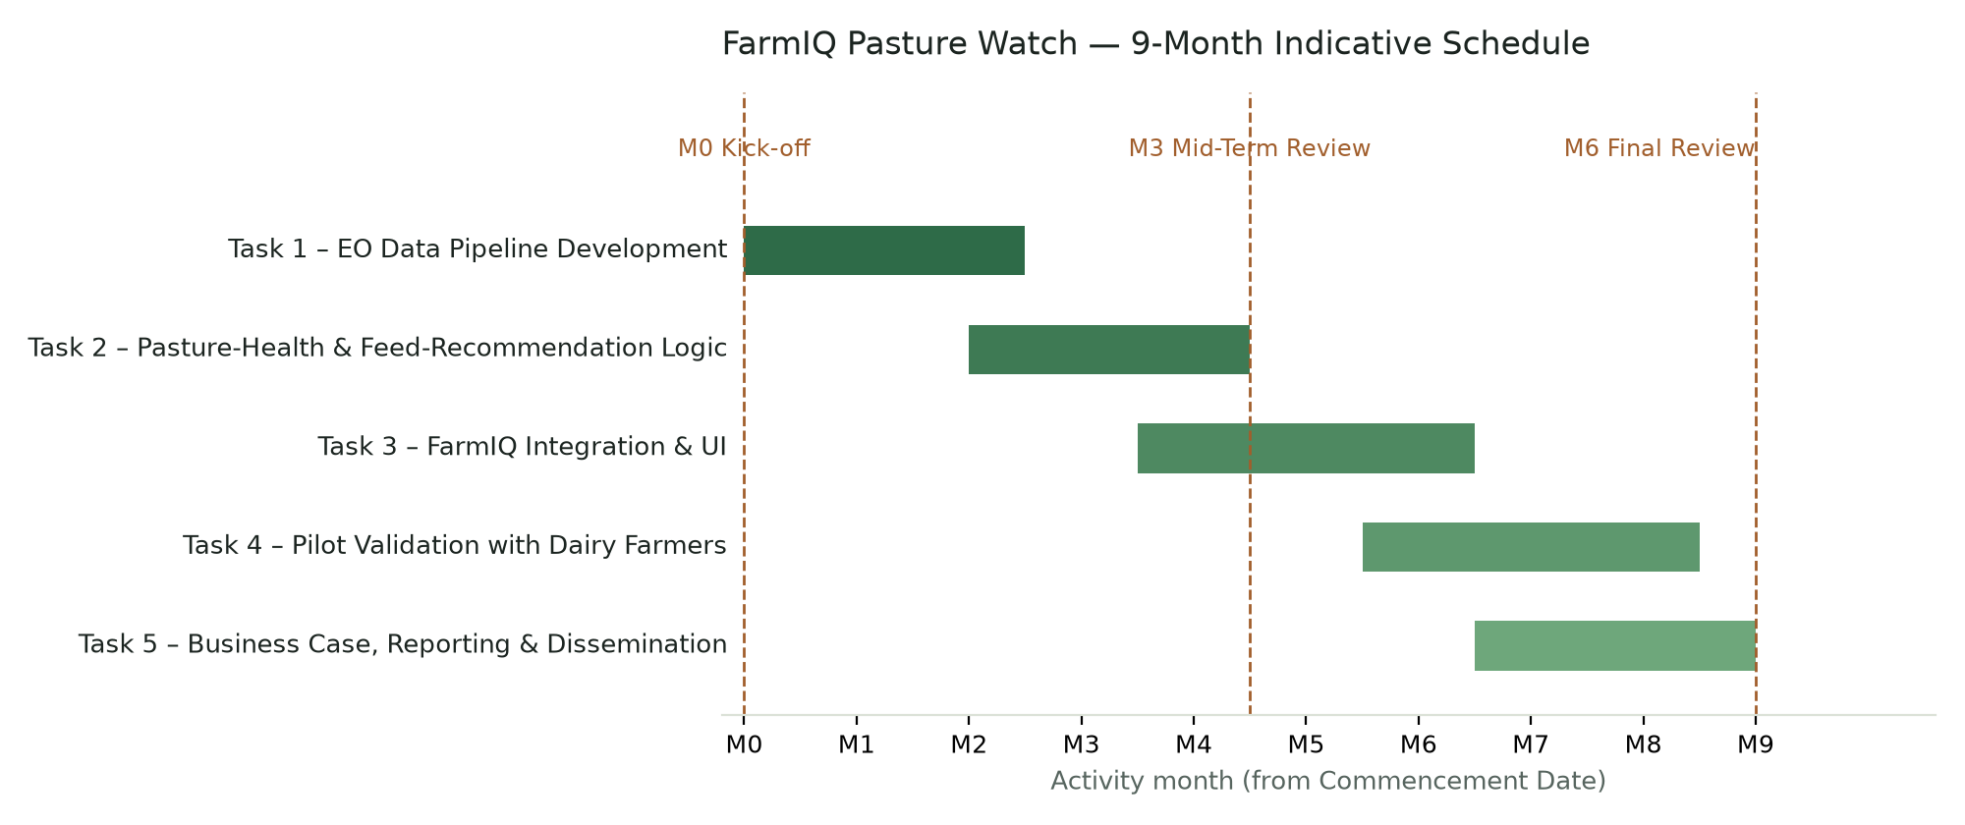
Milestone | Indicative Timing | Description
M0 – Kick-off Meeting | Month 0 | Contract signature, kick-off with ABIL Office, registration in relevant ESA systems
M1 | Month 2 | Requirements finalised; pilot farms/plots selected; EO data pipeline design complete
M2 | Month 4 | Working NDVI/EVI ingestion pipeline against pilot farm plot boundaries
M3 – Mid-Term Review | Month 4–5 | Mid-Term Report and presentation; prototype pasture-health indicator demonstrated
M4 | Month 6–7 | Pasture-health signal integrated into FarmIQ cow/feeding module; pilot farmer field validation
M5 | Month 8 | Business case, commercialisation roadmap and Proof of Achievement materials drafted
M6 – Final Review | Month 9 | Final Report, Final Data Package, Proof of Achievement Slide Deck and demonstration item delivered

3.2 Work Breakdown

Task 1: EO Data Pipeline Development
Task # | 1 |  | Start date: |  | MONTH 0
Task Title: | EO Data Pipeline Development |  | End date: |  | MONTH 2
Task Manager | Stanley Munene (CFO/CTO)
Objective(s) | Build a reliable Sentinel-2 NDVI/EVI ingestion and storage pipeline against registered farm plot boundaries.
Inputs | Sentinel-2 open data; existing FarmIQ geomap plot boundary data
Sub-tasks | Data source integration; index computation; scheduled processing; time-series storage
Output & Deliverables | Working EO data pipeline; technical documentation
Cost | Total Amount (EUR) | ESA EXPLORE Funding (EUR) |  | Other Sources
Cost | 5500 | 5500

Task 2: Pasture-Health & Feed-Recommendation Logic
Task # | 2 |  | Start date: |  | MONTH 2
Task Title: | Pasture-Health & Feed-Recommendation Logic |  | End date: |  | MONTH 4
Task Manager | Stanley Munene (CFO/CTO)
Objective(s) | Translate the vegetation index time series into a farmer-facing pasture-health status and feeding recommendation.
Inputs | Task 1 outputs; FarmIQ existing feeding/milk-yield records
Sub-tasks | Threshold/trend logic design; correlation analysis with existing feeding & yield data; validation approach definition
Output & Deliverables | Documented pasture-health logic; validation results
Cost | Total Amount (EUR) | ESA EXPLORE Funding (EUR) |  | Other Sources
Cost | 4900 | 4900

Task 3: FarmIQ Integration & UI
Task # | 3 |  | Start date: |  | MONTH 3
Task Title: | FarmIQ Integration & UI |  | End date: |  | MONTH 6
Task Manager | Emmanuel Keter (CEO)
Objective(s) | Surface the pasture-health indicator and alerts inside FarmIQ’s existing cow/feeding module and notification channels.
Inputs | Task 2 outputs; existing FarmIQ UI/notification infrastructure
Sub-tasks | UI design; WhatsApp/in-app alert integration; PWA support
Output & Deliverables | Integrated feature in FarmIQ (demonstration item / prototype)
Cost | Total Amount (EUR) | ESA EXPLORE Funding (EUR) |  | Other Sources
Cost | 6600 | 6600

Task 4: Pilot Validation with Dairy Farmers
Task # | 4 |  | Start date: |  | MONTH 5
Task Title: | Pilot Validation with Dairy Farmers |  | End date: |  | MONTH 8
Task Manager | Michael Mirera (Portfolio Manager)
Objective(s) | Validate the feature with Miginon Farm and, where secured, an additional pilot farm/cooperative, and collect feedback and evidence of value.
Inputs | Task 3 deliverable; pilot farm access
Sub-tasks | Pilot recruitment; field validation; farmer feedback collection; KPI measurement
Output & Deliverables | Validation report; farmer feedback; evidence for Final Report
Cost | Total Amount (EUR) | ESA EXPLORE Funding (EUR) |  | Other Sources
Cost | 6000 | 6000

Task 5: Business Case, Reporting & Dissemination
Task # | 5 |  | Start date: |  | MONTH 6
Task Title: | Business Case, Reporting & Dissemination |  | End date: |  | MONTH 9
Task Manager | Emmanuel Keter (CEO)
Objective(s) | Refine the exploitation pathway/business case and prepare all ABIL EXPLORE deliverables.
Inputs | All prior task outputs
Sub-tasks | Commercialisation roadmap; Mid-Term & Final Reports; Proof of Achievement slide deck and demonstration item
Output & Deliverables | Mid-Term Report; Final Report; Final Data Package; Proof of Achievement
Cost | Total Amount (EUR) | ESA EXPLORE Funding (EUR) |  | Other Sources
Cost | 4400 | 4400

3.3 Cost Planning
The maximum ABIL EXPLORE contribution is EUR 50,000 per funded activity. The budget below is a reasoned draft, built from Kenya-market cost assumptions rather than final invoiced figures — AppCross should true it up against actual payroll and contract costs before submission. Requesting EUR 27,400 (about 55% of the ceiling) reflects a lean scope that reuses the existing FarmIQ codebase; there is headroom to increase personnel time, add a second pilot site incentive, or draw down further toward the EUR 50,000 ceiling if AppCross judges the activity needs it.

Overall Cost
Task | Total Amount | ESA EXPORE Funding | Other Sources
Task 1 – EO Data Pipeline Development | 5,500 | 5,500 | —
Task 2 – Pasture-Health & Feed-Recommendation Logic | 4,900 | 4,900 | —
Task 3 – FarmIQ Integration & UI | 6,600 | 6,600 | —
Task 4 – Pilot Validation with Dairy Farmers | 6,000 | 6,000 | —
Task 5 – Business Case, Reporting & Dissemination | 4,400 | 4,400 | —
Total | 27,400 | 27,400 | —

Cost category assumptions
Cost category | Amount (EUR) | Basis
Personnel (9 months, part-time allocation) | 18,200 | Stanley Munene (CFO/CTO, ~55% average time) EUR 7,400 — leads the technical EO build (Tasks 1–2) plus lighter CFO financial oversight throughout; Emmanuel Keter (CEO, ~45% average time) EUR 6,100 — overall project management throughout, plus hands-on leadership of product integration (Task 3) and business case/reporting (Task 5); Michael Mirera (Portfolio Manager, ~35% average time) EUR 4,700 — concentrated on the farmer/pilot-partner relationship (Task 4), with lighter input to customer-facing elements of Tasks 2 and 5. Assumes a blended EUR ~1,500/month cost per team member, reflecting typical Nairobi mid-level tech/finance role compensation inclusive of statutory contributions.
Short-term GIS/remote-sensing specialist (contingent) | 3,000 | Reserved in case a specific skills gap is identified during Task 1 (Section 2.1.2); not committed in advance.
Cloud / hosting | 700 | FarmIQ Pasture Watch will be deployed on Vercel (Pro plan, 2 seats, ~USD 20/seat/month) with Neon Postgres (Pro/Launch tier, usage-based) as the database — approximately USD 60–65/month combined, for 9 months. Sentinel-2 data itself remains free under the Copernicus open data policy (Section 2.3.4); this line covers application hosting and database only.
Field validation & travel | 1,500 | Nairobi–Kericho return visits to Miginon Farm across the activity, plus outreach travel to secure and validate with an additional pilot farm or cooperative (Section 2.2.4).
Software / testing tools | 500 | Minor paid developer/testing tooling, if required.
Dissemination materials | 1,000 | Production of the Proof of Achievement slide deck and demonstration video/item (Annex A, D1).
Contingency (~10% of subtotal) | 2,500 | Standard contingency against schedule or scope risk.

[Before submission: confirm actual personnel cost/time allocation, Vercel/Neon usage-tier pricing at the time of the application (rates change), and whether VAT applies to any of these line items — the ABIL EXPLORE contribution must be quoted net of VAT.]

3.4 Key Resources and Facilities
- EO data: Sentinel-2 imagery (Copernicus open data, free)
- Hosting: FarmIQ Pasture Watch will be deployed on Vercel (application hosting) with Neon (managed serverless Postgres) as the database — both already selected as the deployment stack for this activity (see Section 3.3 for cost basis)
- Software: existing FarmIQ Django codebase (geomap, cows, crops, notifications modules)
- Pilot/field validation access: Miginon Farm (~25 acres, Chepsir, Kipkeleon West, Kericho County) — existing FarmIQ beta-testing partner since 13 May 2026, growing Napier grass, maize, sweet potato, Desmodium and Boma Rhodes hay, and operating its own silage-making programme; committed as the primary pilot site for this activity (Letter of Support attached).
No additional pilot farms, GIS/remote-sensing tools or subcontractor facilities are confirmed at this time beyond Miginon Farm; as noted in Section 2.2.4, AppCross recommends securing at least one further pilot farm or a Kericho County dairy cooperative before submission to broaden validation beyond a single site. All software, cloud and EO-data resources listed above are already available in-house; no new resource acquisition is required to begin the activity.

Management Proposal

General Management (1 page):
Emmanuel Keter, CEO of AppCross Company Limited, will act as Project Manager for this activity, holding day-to-day responsibility for overall coordination, budget oversight, and formal correspondence with the ABIL Office, ESA and KSA (Article 6 of the Draft Contract). Emmanuel Keter is also Task Manager for Task 3 (FarmIQ Integration & UI) and Task 5 (Business Case, Reporting & Dissemination), as set out in Section 3.2.
Reporting lines are kept flat, appropriate to a three-person delivery team:
- Emmanuel Keter (CEO, Project Manager) — overall coordination; Task Manager for Tasks 3 and 5
- Stanley Munene (CFO/CTO) — Task Manager for Tasks 1 and 2; reports progress to the Project Manager
- Michael Mirera (Portfolio Manager) — Task Manager for Task 4; reports progress to the Project Manager
Internally, the team will hold a short bi-weekly progress check-in covering task status against the Section 3.1 milestone schedule, open risks from the Section 2.3.5 risk register, and any blockers. In addition, the team will meet the Draft Contract’s formal meeting requirements (Appendix 1): a Kick-off Meeting at the start of the Contract Term, a Mid-Term Review around Month 4–5, and a Final Review at Month 9 — each minuted and distributed within ten (10) days, as required by Appendix 1, Section 2.1.
Deliverables (the Mid-Term Report, Final Report, Proof of Achievement Slide Deck and demonstration item, and the Final Data Package — Article 2 of the Draft Contract) will be tracked against the Section 3.2 Work Breakdown and consolidated by the Project Manager, with each Task Manager directly accountable for the outputs of their own task.
Coordination with Miginon Farm, the activity’s pilot partner (Section 2.2.4), will be led by Michael Mirera as Portfolio Manager, who will be the team’s primary point of contact for pilot visits, feedback collection, and any additional pilot farm/cooperative outreach under Task 4.
Disagreements within the project team will first be resolved by team consensus; where consensus cannot be reached on a day-to-day operational matter, Emmanuel Keter, as CEO and Project Manager, holds final decision authority. Any matter affecting AppCross Company Limited’s broader governance would be escalated to AppCross’s Board of Directors.

Annexes
- Initial Exploitation Pathway / Business Model Canvas
- Curriculum Vitae of the members of the Project team
- Letter(s) of support from customers, users, technology/data providers or other relevant stakeholders if any
- Any other relevant information about the activity or the Applicant, eligibility as Kenyan start-up/SME, access to data/technology/IP, or the proposed EO innovation, as necessary

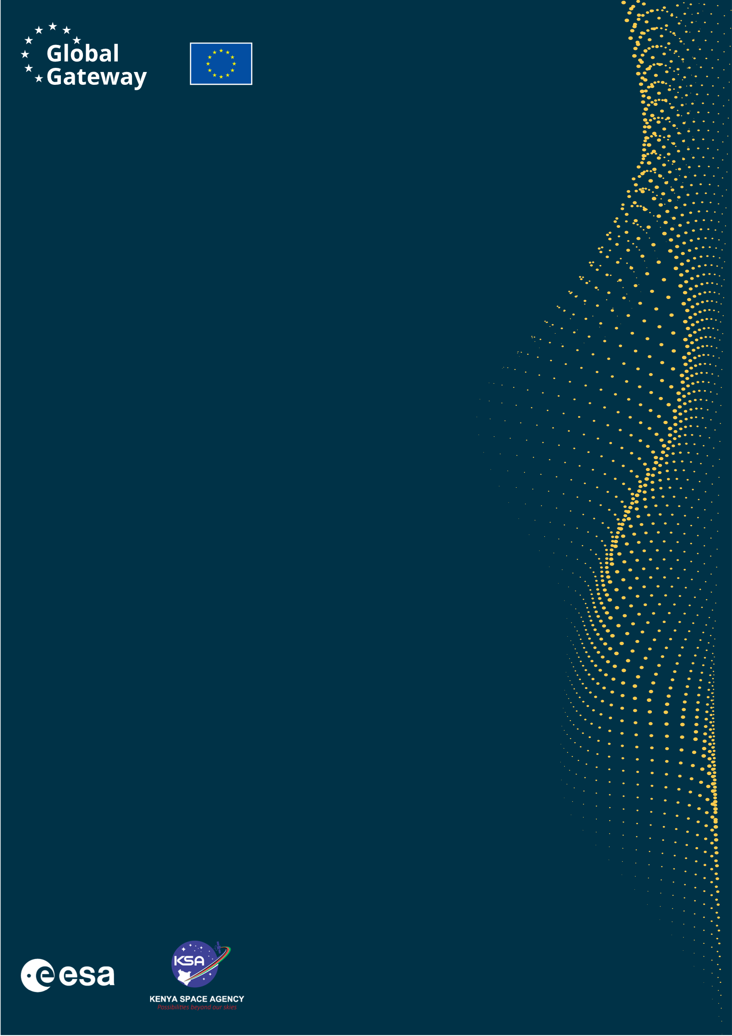

Africa–EU Space Partnership Programme
Africa Business Innovation Lab (ABIL)

WEB https://abil.ksa.go.ke/
TAGS #GlobalGatway #AESPP #ABIL

Please have the form signed by all natural persons whose personal data is provided as part of the application.

